**Project Title:** Competitor Analysis AI Bot

**Brief Description:** Developed an AI-powered Competitor Analysis Bot designed to provide businesses with a competitive edge by identifying competitors and analyzing their website traffic. The bot leverages advanced AI to uncover hidden opportunities and exploit competitor weaknesses, enabling strategic decision-making and unlocking growth potential. The solution is fully automated, running every 15 minutes to ensure up-to-date insights.

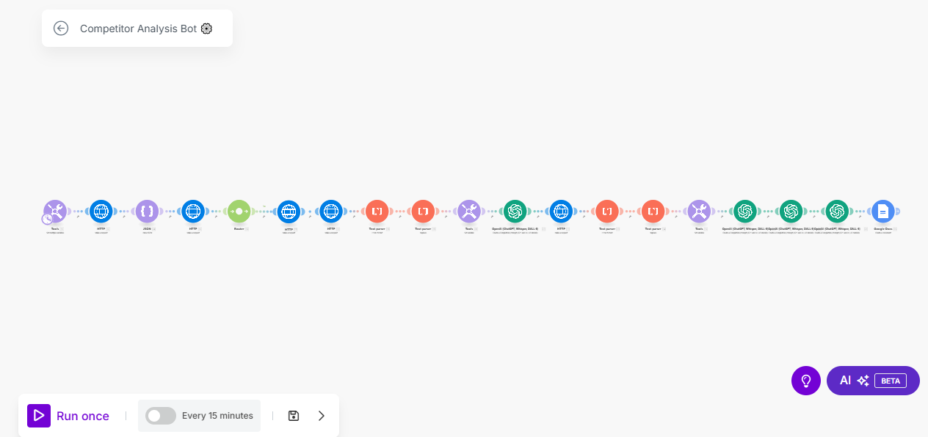

**Skills Used:** AI integration, data analysis, automation, strategic planning, and workflow optimization using Make.com. The bot utilizes ChatGPT for intelligent analysis and decision-making, ensuring high accuracy and relevance in the insights provided.

**Relevant Outcomes/Achievements:** Successfully implemented a zero-coding, plug-and-play solution that runs on autopilot, making it accessible for businesses of all sizes. The bot’s fully customizable nature allows for tailored analysis, ensuring it meets specific business needs. This project has empowered businesses to make data-driven decisions, leading to improved market positioning and increased growth opportunities. The easy setup and seamless integration have resulted in high user satisfaction and adoption rates.

**Key Features:**

* Automated competitor identification and traffic analysis.
* AI-driven insights for strategic decision-making.
* Fully customizable and adjustable to specific business requirements.
* Zero coding required, ensuring ease of use for non-technical users.